CM3070 - Final Project - Financial Advisor Bot
David Jackson
Table of Contents
CM3070 - Final Project - Financial Advisor Bot 1
Introduction 2
Chosen Template 2
Project Concept 2
Motivation 2
Why is this a good fit for the Final Project? 3
Literature Review 3
Using LSTM for Time Series Predictions 3
Selecting Technical Indicators 4
Reinforcement Learning for Portfolio Management 5
Identified Gaps 6
Conclusions 6
Design 7
Target Users 7
Technical Architecture 7
LSTM Model 8
Reinforcement Learning Model 9
LangChain Agent Architecture 11
Next.js Frontend Application 12
Implementation 13
LSTM Model Training and Predictions 13
PPO Model Training and Predictions 17
User Application and API 20
Evaluation 21
Evaluation Method 21
LSTM Signal Generator 21
PPO Agent Portfolio Performance 22
User Testing 24
Conclusion 27
Bibliography 27
References 27

Introduction

Chosen Template
For this project I chose the “Project Idea: 2 Financial Advisor Bot” template. The project involves designing and implementing an AI system with a user-facing application, evaluating its performance using quantitative metrics, and testing the output with real users.

Project Concept
I am building a financial advisor bot that analyses stock market data and gives a non-technical retail investor a plain-language recommendation about whether a stock looks like a buy, sell, or hold. The application considers a portfolio of stocks rather than looking at each stock in isolation. This means the recommendation for one ticker accounts for the user's positions in other tickers, so the system makes decisions based on the overall portfolio state. This balances potential risk and reward. The first version focuses on equities listed on the TSX, NYSE, and NASDAQ exchanges. I use daily historical price data from the yfinance library. The user interacts with the application through a web interface with a primarily chat-based UI.

Motivation
Retail investors have a problem where the tools that exist to help them analyse stocks are either too simple or too complex. Charting applications that show raw price and volume data but leave all interpretation to the user are too simple. Sophisticated quantitative analysis platforms aimed at professional traders or institutional investors are too complex and require domain expertise to use effectively.

There is a gap between these 2 categories for an application geared to a non-technical investor, who owns a portfolio of 5 to 10 stocks. They do not have access to AI-driven analysis that understands their portfolio as a whole and communicates its findings in plain English. Tools like Danelfin come close by using machine learning to score individual stocks. However, Danelfin does not account for portfolio-level context. It assesses each stock as if the user holds nothing else, which means its recommendations can conflict with each other or ignore available cash and existing positions.

This project addresses that gap. It uses a 2-stage AI architecture to separate prediction from decision. What will the stock do tomorrow vs how much should I buy/sell/hold. A plain-language explanation layer then translates the structured model output into advice a non-technical user can understand and act on.

Why is this a good fit for the Final Project?
This is a good fit for the Final Project because it includes building a web application, and designing and evaluating an AI system that makes decisions from data. The project uses historical stock market data as input, trains machine learning models to identify patterns, and then uses those model outputs to produce a recommendation for the user.
The project also fits the template because it includes both model evaluation and user-facing evaluation. The LSTM model can be tested by comparing its predictions against held-out market data. The reinforcement learning agent can be evaluated through back-testing against baseline strategies like buy-and-hold or random actions. The final web application can also be tested with users to see whether the plain-language recommendation is understandable and useful. This gives the project 2 levels of evaluation: whether the AI models perform well, and whether the user can interpret the output correctly.

This is important because the project is not only about prediction accuracy. A stock recommendation system must also explain its reasoning in a way that a non-technical user can understand.

Literature Review
I reviewed 5 peer-reviewed papers centered around the 3 key questions in this project:

- Which is the best algorithm for predicting stock price time series data?
- Which features should be used?
- What is the best algorithm for maximizing the return of a portfolio of stocks?

Using LSTM for Time Series Predictions
LSTM is identified as the machine learning architecture that best predicts stock price direction in 3 out of the 5 papers.
Wei (2019), applies an LSTM with an attention layer to the Shanghai composite, Shenzhen composite, and CSI 300 indices. Wei finds that LSTM predicts directional movement well, but notes a time-lag effect when the training data window is short: predicted peaks and troughs trail real ones by several periods. As the training data window grows from 1 year to 2 years, this lag reduces significantly. Wei uses a fairly small set of features: date, open price, close price, max price, min price, and volume. The input window is 4 days of features and the output is the closing price on the fifth day. This is relevant to my project. If the training window is too short, the LSTM will generate incorrect signals but 2 years is enough data to guarantee good results.
Mostafavi and Hooman (2025) tested 4 model types: XGBoost, Random Forest, SVR, and LSTM. They tested against 88 technical indicators across 73 years of S&P 500 data. The LSTM achieved a mean absolute error of 0.014, Random Forest achieved 1.39, XGBoost achieved 4.89, and SVR achieved 7.76. They came to the conclusion that financial data is inherently sequential and prices are not independent observations. LSTM's gated memory structure lets it retain relevant signals across time while ignoring noise in a way that tree-based or kernel-based models cannot.
Ding and Qin (2020) argue that most LSTM implementations treat open, high, low, and close prices as independent prediction targets. This is an incorrect assumption as these values are causally related within the same trading day. The high cannot be lower than the low, and both depend on where the stock opened. Their associated neural network model uses 3 parallel LSTM branches whose outputs feed into each other, encoding this causal structure. Their model was tested on Chinese equity indices and achieves above 95% accuracy and outperforms standalone LSTM baselines. In my solution I include all OHLCV columns together so the model can learn their within-day relationships rather than treating each column independently. Ding and Qin (2020) find a 20-day lookback window is most efficient and Zou et al. (2024) find that a 30-day lookback window produces the best results.
Together these 3 papers answer my first question:
Long Short-Term Memory implementations are the best algorithms for predicting time series stock prices.

Selecting Technical Indicators
Mostafavi and Hooman (2025) used Principal Component Analysis (PCA) to reduce their original 88 features down to 35 while retaining 95% of the dataset variance. Included in the top 10 features are HLC3, OBV, TEMA, SMA5, BBL, SMA50, SMA14, FWMA, HWMA, Ichimoku, HMA, PVT, and BBU. Open, close, high, low, and volume were also included. They note that LSTM models do best with temporal dependencies, and prioritize time sensitive indicators such as HLC3 and SMA5.

Zou et al. (2024) take a different approach: they include MACD, RSI, CCI, and ADX as part of the RL agent's observation state. RSI and MACD rank lower in Mostafavi and Hooman's analysis, but their inclusion in Zou et al.'s RL state vector suggests their value may depend on how they are used. These metrics will be good to test if I do not have as much success as Mostafavi and Hooman.

Together these two papers answer my second question:

HLC3, OBV, TEMA, SMA5, BBL, SMA50, SMA14, FWMA, HWMA, Ichimoku, HMA, PVT, and BBU are the best features to use for LSTM

Reinforcement Learning for Portfolio Management
Zou et al. (2024) present an architecturally similar implementation to the 2-stage design I am proposing. They argue that standard deep reinforcement learning methods were originally built for games and do not naturally capture temporal dependencies in financial time-series data. This is because many DRL agents process raw state vectors using MLP or convolutional layers that have no memory. Their solution is a CLSTM-PPO model, which combines an LSTM-based encoder with a PPO reinforcement learning agent.

The model uses a cascaded structure. First, an LSTM processes a rolling window of 30 market state vectors and compresses them into feature encoding. This encoding is then passed to a PPO agent whose actor and critic networks are also LSTM models. The state vector includes available balance, stock prices, shareholdings, and 4 technical indicators: MACD, RSI, CCI, and ADX. The agent can buy, sell, or hold each stock, and the reward is based on the change in total portfolio value per trading period.

The model is tested across 4 markets: the Dow Jones 30, SSE 50, SENSEX, and FTSE 100. It consistently outperforms 6 baselines, including a published strategy using PPO, A2C, and DDPG. In the Chinese market, CLSTM-PPO achieves a cumulative return of 222.91% against 120.87% for the next-best method. The paper also finds that a 30-day lookback window for LSTM produces the best results. I use this as the starting point when choosing the rolling window length for my Stage 1 LSTM.

The main difference from my project is that CLSTM-PPO uses LSTM as a temporal encoder inside the RL system rather than as a separate upstream prediction model. I am separating these concerns deliberately: my LSTM is trained to output a predicted close value, and the RL agent is trained separately to act on that signal in the context of the portfolio. Zou et al. show that a combined LSTM-PPO approach works on equity markets, which validates my choice of PPO as the algorithm for Stage 2.

Jiang et al. also introduce the Ensemble of Identical Independent Evaluators (EIIE), where each asset is evaluated by the same shared model and then converted into portfolio weights. I am not using the full EIIE architecture, but the idea is still relevant because it shows that an RL agent can evaluate multiple assets together rather than treating each trade in isolation. Their experiments use cryptocurrency data at 30-minute intervals, while my project uses daily OHLCV equity data from yfinance. This is a limitation because patterns at 30-minute frequency may not transfer directly to daily stock data.

Zou et al. (2024) help address this limitation because they apply a closely related LSTM-PPO approach to daily equity markets, including the Dow Jones 30 and FTSE 100. They also find that PPO outperforms A2C and DDPG. I use PPO for this reason. Together, Jiang et al. (2017) justify considering portfolio management as an RL problem, while Zou et al. (2024) support using PPO for daily equity data.

This answers my third question:

PPO is the best algorithm for maximizing the return of a portfolio of stocks.

Identified Gaps
Jiang et al. (2017) argue that separating prediction from decision is a limitation since the 2 layers are not optimised together. Zou et al. (2024) integrate them tightly in a CLSTM-PPO architecture and achieve strong results. I am intentionally separating the 2 stages so that the LSTM signal can be built and tested independently. This might make my system lose performance compared to a fully integrated approach.

The most significant gap across all 5 papers is that none of them address how to make the output of an LSTM-RL system accessible to a non-technical user. Every paper assumes the system is operated by a researcher or quantitative trader who can interpret raw model outputs directly. This project fills that gap by adding a plain-language explanation layer that translates the structured recommendation into advice a retail investor can understand and act on.

Conclusions
Reading across all five papers, a few consistent findings stand out. First, LSTM outperforms simpler architectures on financial time-series tasks in every paper that makes the comparison. Wei (2019), Ding & Qin (2020), and Mostafavi & Hooman (2025) all reach the same conclusion. Second, the separation between prediction and decision-making that I have designed into the project is supported by Jiang et al. (2017) and Zou et al. (2024). Both papers show that RL agents working from temporal market representations outperform agents working from raw features or hand-coded rules. Third, input window length and feature selection both have measurable effects on model quality. The 30-day window identified by Zou et al. (2024) and the lag findings in Wei (2019) both point toward using at least 20 to 30 trading days as the lookback period for LSTM training.

One key difference between the papers and my approach is how tightly the prediction and decision layers are connected. Jiang et al. (2017) and Zou et al. (2024) train both layers together as one system. I am training them separately, with the LSTM producing a signal that the RL agent then acts on. This separation makes the system easier to interpret since I can examine the LSTM signal on its own. The trade-off is that the LSTM is not trained to produce signals that specifically help the RL agent maximise returns, so the combined performance may be lower than a fully integrated approach. This is a limitation I have recognized and something I would look to explore further if I extend the project.

Design

Target Users
The target user is a non-technical retail investor managing a portfolio of equities listed on the TSX, NYSE, and S&P 500 exchanges. They understand what stocks they own but do not have the time, expertise, or tools to analyse market signals across a portfolio as a whole.

Existing tools such as Danelfin use decision trees applied to individual stocks without temporal context, and do not account for portfolio-level state. Fully integrated LSTM-RL systems (Jiang et al., 2017; Zou et al., 2024) have shown strong performance but are not accessible to non-technical users via a natural language interface. This project bridges that gap by combining a 2-stage AI architecture with a plain-language advisory layer.

Technical Architecture
The system is designed as an offline training pipeline and an online advisor application. The offline pipeline downloads historical OHLCV data through yfinance, generates technical features, trains the LSTM, and is intended to train and back-test the PPO agent. The online design uses a Next.js chat interface with a FastAPI backend and a LangChain agent backed by Ollama. This separates model training from live inference and keeps the language model responsible for explanation rather than prediction.

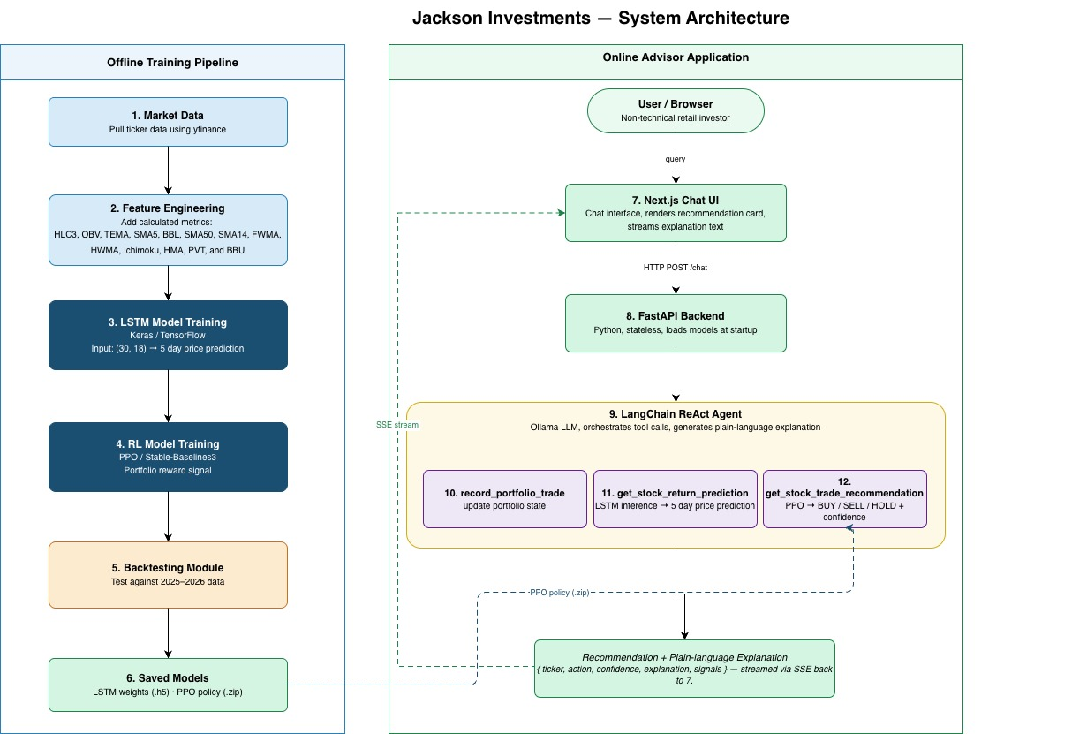
Figure 1. Target system architecture for the financial advisor bot.
The offline pipeline downloads market data, calculates technical features, trains and back-tests the LSTM and PPO models, and saves the trained models for inference. In the frontend application, the Next.js interface sends user queries to the FastAPI POST /chat endpoint. A LangChain ReAct agent uses Ollama to orchestrate portfolio updates, LSTM return predictions, and PPO-based trade recommendations. The response is streamed back in plain-language to the user.

LSTM Model
Ding and Qin (2020) propose a model that consist of three parallel LSTM architectures each consisting of the following layers:

- Input Layer
- LSTM Layer
- Dropout Layer
- LSTM Layer
- Dropout Layer
- Output Layer

I used a 30-day input window with 18 features per day because Zou et al. (2024) found that this window produced the best results. The implemented target is the return after 5 trading days. This is a regression task, so the final Dense layer uses a linear output rather than a Sigmoid activation.

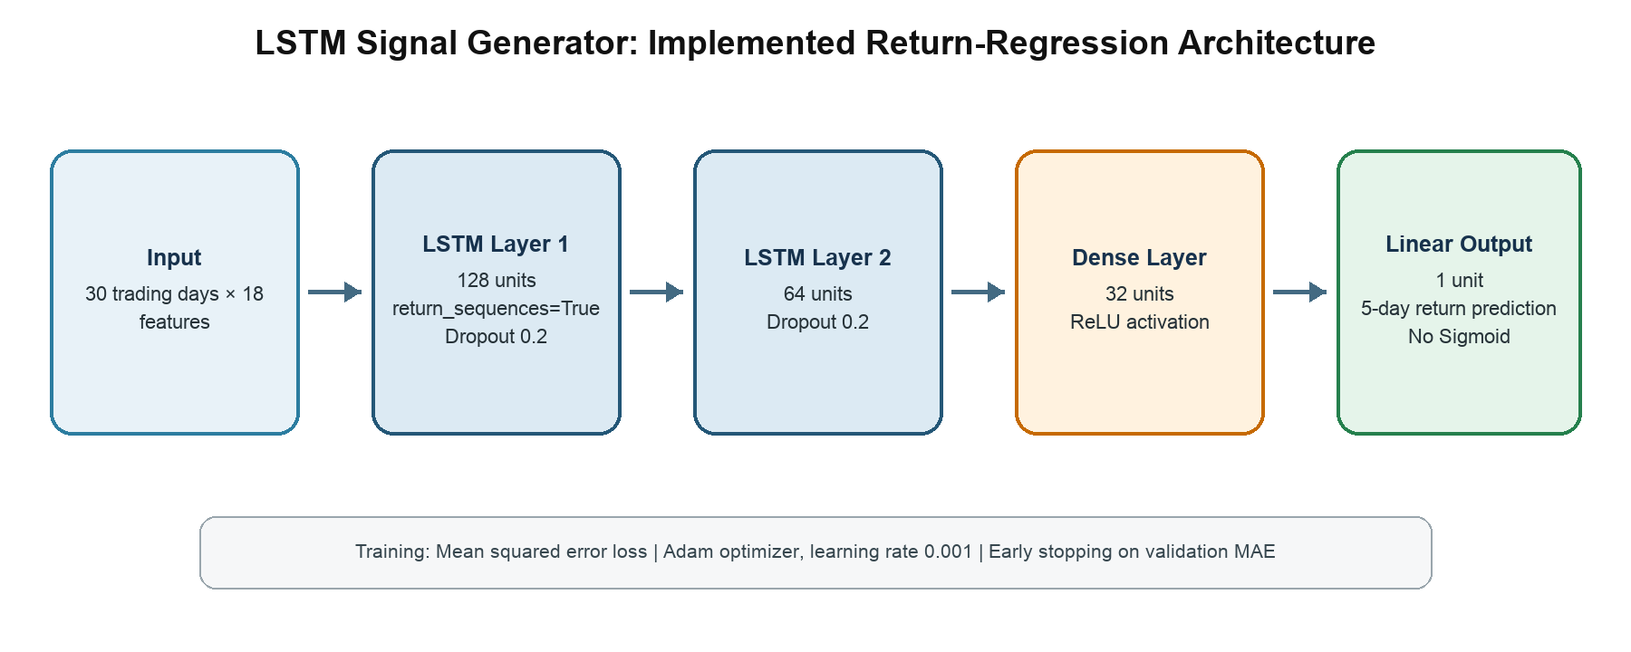
Figure 2. Implemented LSTM architecture for 5-day return regression.

Wei (2019) used a gradient descent optimizer with a learning rate of 0.001. They also include an attention layer after the LSTM layer, which helps identify which features are most important. They do not describe the layer clearly, so I kept attention as a possible later improvement. I used the Adam optimizer with a learning rate of 0.001.

Wei (2019) tested 12, 18, and 24 months of training data and found that 24 months was the best of those options. Mostafavi and Hooman (2025) found that 500 days was sufficient. I used a 2-year training period in the notebook experiments. The standalone training script now keeps a rolling 2-year training period, followed by 1 year for validation and 1 year for testing, with the dates anchored to the day the script runs.

Reinforcement Learning Model
I will use a reinforcement learning agent with Proximal Policy Optimization (PPO) from the Stable-Baselines3 library. This design is based on Jiang et al. (2017), who treat portfolio management as a reinforcement learning problem rather than a simple prediction problem. Their argument is that forecasting prices and then applying hand-coded trading rules creates a gap between prediction and decision. A model might predict that a stock will rise, but that does not automatically mean the system should buy it. The decision also depends on cash, current holdings, transaction costs, and the rest of the portfolio.
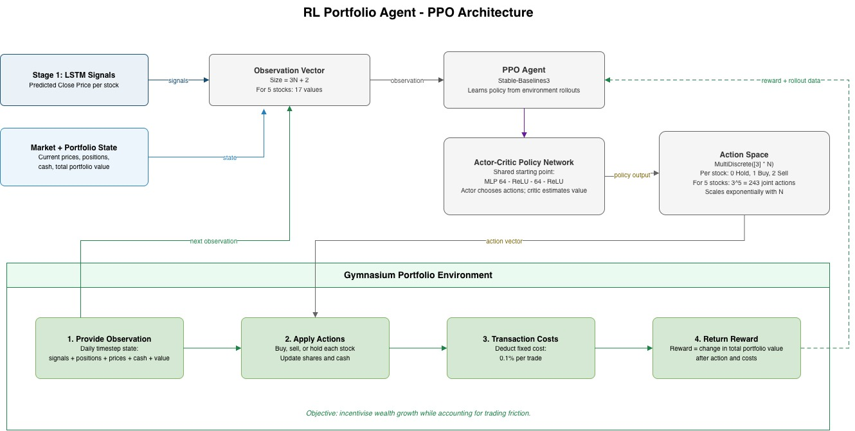
Figure 3. PPO portfolio-agent architecture.

Environment
The agent works inside a Gymnasium environment that simulates the portfolio. At each daily timestep, the observation will include the LSTM signals, normalised position, normalised price for each stock, the cash ratio, and the portfolio value ratio. The action space will be MultiDiscrete, giving a hold, buy, or sell decision for each stock each day. The reward will be the change in total portfolio value after deducting a 0.1% transaction cost. This follows the same principle as Jiang et al. (2017), where the agent is rewarded for improving portfolio value while accounting for the cost of trading.

Observation space
For a portfolio of N stocks, the observation at each timestep is a vector containing:
Component | Size | Description
LSTM signal per stock | N | Close price prediction from Stage 1
Current position per stock | N | Number of shares currently held, normalised
Current price per stock | N | Latest closing price, normalised
Available cash ratio | 1 | Cash available compared to total portfolio value
Total portfolio value | 1 | Current total value, normalised

Total observation size: (3N + 2). For an initial portfolio of 5 stocks this gives a 17-dimensional state vector.

Action space
PPO works well with a MultiDiscrete action space. It will use one of 3 actions (0 = Hold, 1 = Buy, 2 = Sell) per stock per timestep. For 5 stocks this produces 3⁵ = 243 possible action combinations which is fine however the number of actions grows exponentially so it would become a problem to have a large portfolio.

Reward function
The reward at each timestep is the change in total portfolio value after applying the action and deducting a fixed transaction cost of 0.1% per trade. This is consistent with the cost structure used by Jiang et al. (2017). Using portfolio value change as the reward means the agent is incentivised to grow wealth.

Policy network
I will use a two-layer MLP with 64 units per layer and ReLU activations for both the actor and critic networks. This is the default Stable-Baselines3 architecture and I will use it as the starting point before any hyperparameter tuning.

LangChain Agent Architecture
The backend uses a LangChain agent as the orchestration layer. The agent receives the user's natural-language query and decides which tool to call. This lets the user ask a flexible question while keeping all numeric predictions, portfolio lookups, and trade decisions inside controlled application code rather than asking the language model to guess.

I registered 4 tools with the agent:
- get_stock_return_prediction takes a ticker symbol, builds the latest 30-day feature window, runs the saved pooled LSTM model, and returns the predicted 5-day return and close price.
- get_portfolio_positions looks up the user's current cash balance and share holdings.
- get_portfolio_trade_recommendation asks the trained PPO agent what to do (buy, sell, or hold) with each of the 5 tickers it was trained on. It reads the user's actual cash and holdings before deciding, so the recommendation reflects their real portfolio rather than a fresh simulated one, and returns the action, current price, holding size, and signal strength for each ticker.
- record_portfolio_trade logs a buy or sell the user says they already made, priced at the ticker's latest close rather than whatever price the user may have actually paid, and returns the updated cash balance and holdings.

I am using a system prompt that instructs the agent to use get_stock_return_prediction for a stock's near-term outlook and get_portfolio_trade_recommendation for portfolio-wide trading advice. For a trade recommendations, the prompt requires a plain-language explanation of each action alongside the reasoning available from the tool (current price, holding size, signal strength), and a warning that the result is a trained model's suggestion rather than financial advice. When the user mentions a trade they already made, the prompt requires the agent to call record_portfolio_trade and confirm what the user said, or explain in plain language why the trade could not be saved.

Next.js Frontend Application
The user-facing part of the system is built using Next.js. I created a chat component using Shadcn primitives that lets the user interact with the Langchain agent and ask questions in plain English.

The main screen is a portfolio-aware chat interface. The user can enter ticker symbols and share quantities for the stocks they currently hold. They can then ask questions such as “Should I buy more AAPL?” or “What should I do with my portfolio today?”. The portfolio state is stored in a SQL database in the backend and referenced by the tools.

Implementation
The implementation is grouped into three categories: LSTM model training and predictions, PPO Model training and predictions, and the user application/api.

LSTM Model Training and Predictions
The LSTM part of the application has 2 purposes. The first is to provide a live 5-day return prediction when the user asks about a stock. The second is to generate historical signals for the PPO portfolio agent. Both processes use the same feature preparation and model architecture, but I trained and saved separate models because they use different time periods.

Preparing Data
I downloaded daily stock data using the yfinance library. For each ticker, the downloaded data contains the adjusted open, high, low, close, and volume values. I checked the Open, High, Low, Close and Volume data for unusually large or small values using the interquartile range. Values that were more than 3 interquartile ranges outside the middle 50% of the data were treated as possible outliers and replaced using values estimated from the surrounding trading days.

I generated 18 features from the cleaned data. These include the original OHLCV values and 13 derived indicators: HLC3, OBV, PVT, TEMA, SMA5, SMA14, SMA50, FWMA, HWMA, HMA, the upper and lower Bollinger Bands, and the midpoint of the 2 Ichimoku spans. These features represent different aspects of price level, trend and trading volume.

I found that the raw values cannot be compared directly across stocks. For example, a stock priced at $20 and a stock priced at $500 operate on very different scales. I converted each feature into a rolling z-score using the previous 60 trading days. A z-score describes how far the current value is from its recent mean, measured in standard deviations. This puts stocks with different prices onto a comparable scale while retaining information about whether a value is unusually high or low for that stock. I removed rows that did not have enough history to calculate the features.

I then applied a MinMaxScaler to the z-score features. I fitted this scaler using the combined training rows only. The validation and test data were transformed using the same fitted scaler. This is important because fitting a scaler on the full dataset would allow information from the validation or test periods to influence model training.

I converted the data into overlapping 30-day windows. Each input sample has a shape of 30 trading days by 18 features. The prediction target is the percentage return after 5 trading days.

The window-building code also retains the ticker, prediction date and target date for each sample. I used those dates to assign samples to the training, validation and test sets too.

Training Scripts
The standalone training script calculates the dates it uses for training, testing, and validation from the day it runs. It uses 2 years of data for training, 1 year for validation and 1 year for testing. The final test date is 10 days before the run date so that the final samples still have a completed 5-trading-day target.

Code Sample: Train_all_tickers.py (Lines 37-44)
one_day = pd.Timedelta(days=1)
test_end = TODAY - pd.Timedelta(days=TEST_END_BUFFER_DAYS) # 2026-08-31
test_stop = test_end + one_day # 2026-09-01
test_start = test_stop - pd.DateOffset(years=1) # 2025-09-01
validation_end = test_start - one_day # 2025-08-31
validation_start = test_start - pd.DateOffset(years=1) # 2024-09-01
train_end = validation_start - one_day # 2024-08-31
train_start = validation_start - pd.DateOffset(years=2) # 2022-09-01

The implemented architecture matches what is shown in Figure 2. It includes two LSTM layers with 128 units and 64 units respectively. It includes a dropout layer with a rate of 0.2 after each LSTM layer to reduce overfitting. I added a Dense layer with 32 units and a ReLU activation. The last Dense layer has 1 linear output because the model predicts a return.

I trained the model using the Adam optimiser with a learning rate of 0.001 and mean squared error as the loss function. The maximum training length is 30 epochs with a batch size of 128. I used early stopping based on validation MAE with a patience of 5 epochs. This stops training when validation performance has not improved for 5 epochs and uses the weights from the best epoch. I also used a fixed random seed of 42 to make the run more reproducible.

Code Sample: lstm_helpers.py (Lines 222-254)
def build_lstm_model(
input_shape: tuple[int, int],
first_lstm_units: int = 128,
second_lstm_units: int = 64,
dropout_rate: float = 0.2,
dense_units: int = 32,
learning_rate: float = 0.001,
):
from tensorflow import keras
from tensorflow.keras import layers

model = keras.Sequential(
[
layers.Input(shape=input_shape),
layers.LSTM(first_lstm_units, return_sequences=True),
layers.Dropout(dropout_rate),
layers.LSTM(second_lstm_units),
layers.Dropout(dropout_rate),
layers.Dense(dense_units, activation="relu"),
layers.Dense(1),
]
)

model.compile(
optimizer=keras.optimizers.Adam(learning_rate=learning_rate),
loss="mse",
metrics=[
keras.metrics.MeanAbsoluteError(name="mae"),
keras.metrics.RootMeanSquaredError(name="rmse"),
],
)

return model

After training, I converted the scaled test predictions back into normal return values. I then converted each return into a predicted future close price and calculated MAE, RMSE and MAPE. I compared these results with a zero-return baseline, which predicts that the closing price will remain unchanged after 5 trading days. The trained model and both fitted scalers are saved so the application can reuse the same preprocessing and model parameters during inference.

Results and saved models
Training samples: 48312
Validation samples: 24156
Test samples: 24716
Tickers used: 99

Saved model path:
backend/trained_models/lstm_all_tickers_return_regression/all_tickers_5d_return.keras
Saved scalers path:
backend/trained_models/lstm_all_tickers_return_regression/all_tickers_5d_return.scalers.joblib

Single Ticker Predictions
The single-ticker prediction function is used as a tool by LangChain when a user asks for information about a stock. It first checks that the ticker is one of the 99 stocks supported by the model. It then downloads the previous year of data which provides enough history for the 50-day moving average, 60-day z-score and final 30-day input window.
The function generates the same 18 features used during training and selects the most recent window. It transforms the window using the saved feature scaler and reshapes it to 1 × 30 × 18 before passing it to the saved model. The output is converted back to a normal return using the target scaler and then used to calculate the predicted closing price after 5 trading days.

The function returns the ticker, data date, current close, predicted close, predicted return and a buy, hold or sell signal. A predicted return of at least 1% produces a buy signal. A return of no more than -1% produces a sell signal. Values between these thresholds produce a hold signal. The model and scalers are cached after their first use so they do not need to be loaded from disk for every request.

Code Sample: core/predict.py (Lines 56-97)
def predict_stock_return(ticker: str) -> dict:
"""Predict a stock's return over the next 5 trading days using the pooled all-tickers LSTM model."""
ticker = ticker.upper()
if ticker not in TICKERS:
raise ValueError(f"{ticker} is not one of the tickers this model was trained on.")

feature_scaler, target_scaler = _get_scalers()

today = pd.Timestamp.today()
start = (today - pd.Timedelta(days=FEATURE_LOOKBACK_DAYS)).strftime("%Y-%m-%d")
end = (today + pd.Timedelta(days=1)).strftime("%Y-%m-%d")
df = get_ticker_features(
ticker=ticker,
start=start,
end=end,
smooth_outliers=True,
)

latest_window = df[FEATURE_COLS].dropna().tail(WINDOW_SIZE)
if len(latest_window) < WINDOW_SIZE:
raise RuntimeError(f"Not enough recent {ticker} data to build a prediction window.")

scaled_window = feature_scaler.transform(latest_window)
model_input = scaled_window.reshape(1, WINDOW_SIZE, len(FEATURE_COLS)).astype("float32")

model = _load_model()
scaled_prediction = model.predict(model_input, verbose=0)
predicted_return = float(inverse_scale_predictions(target_scaler, scaled_prediction)[0])

current_close = float(df["Close"].iloc[-1])
predicted_close = current_close * (1 + predicted_return)
as_of_date = df.index[-1]

return {
"ticker": ticker,
"as_of_date": str(as_of_date.date()),
"current_close": round(current_close, 2),
"predicted_close_5d": round(predicted_close, 2),
"predicted_return_5d": round(predicted_return, 4),
"predicted_return_5d_pct": f"{predicted_return:+.2%}",
"signal": _signal_from_return(predicted_return),
}

PPO Signal Training
I trained a separate LSTM to generate the historical input signals used by the PPO agent. The LSTM uses data from 2015 to 2018 for training, 2019 for validation and 2020 for its initial test. It uses the same 30-day window, 5-day return target, architecture and scaling process as the live prediction model. After training, I froze the LSTM model and its scalers. I then use this model to produce walk forward predictions one date at a time without updating its weights. For every date, each prediction uses only the current and previous 29 date data rows. This produces a continuous series of predicted returns beginning in January 2020.

The PPO implementation is designed to support a portfolio of stocks. In my experiments I found that utility stocks had the lowest MAE so I used 5 utilities stocks: NEE, SO, DUK, AEP and EXC. For each trading day, I ranked the 5 predicted returns against each other and converted them into percentile signals. With 5 stocks, these values are 0.2, 0.4, 0.6, 0.8 and 1.0. A value of 1.0 means the stock had the highest predicted return in the portfolio on that date. This converts the LSTM output into a relative signal that PPO can compare across stocks.

Using percentile ranks makes the PPO input stable even when the scale of the LSTM predictions changes. However, it also removes the magnitude and absolute direction of the prediction. The highest-ranked stock receives a signal of 1.0 even if all 5 predicted returns are negative. This is a limitation of the current implementation and I discuss it further in the conclusion.

Code Sample: core/lstm_helpers.py (Lines 302-304)
def convert_returns_to_signals(predicted_returns: pd.DataFrame) -> pd.DataFrame:
# Rank each date's tickers against each other, so the signal stays between 0 and 1.
return predicted_returns.rank(axis=1, pct=True).astype(np.float32)

PPO Model Training and Predictions

Custom Gymnasium environment
I implemented a custom Gymnasium environment to simulate daily portfolio decisions. The environment combines historical stock prices, LSTM signals and the current portfolio state. Each episode begins with $100,000 in cash and no shares. On each trading day, the agent chooses an action for every stock, the environment simulates those trades, and the portfolio is valued using the following day’s prices.

The observation space contains three values for each stock: its LSTM signal percentile, its share of the total portfolio value, and its current price divided by its price at the start of the episode. It also includes the proportion of the portfolio held as cash and the total portfolio value divided by the initial $100,000. With 5 stocks, this produces 17 input values. These ratios allow the agent to consider both market signals and its existing allocation.

Code Sample: core/portfolio_env.py (Lines 84-101)
def _get_observation(self) -> np.ndarray:
current_prices = self.prices[self.current_step]
# Floor the denominator so a near-zero portfolio can't divide by zero.
portfolio_value = max(self._portfolio_value(current_prices), self._MIN_PORTFOLIO_VALUE)
position_ratios = self.holdings * current_prices / portfolio_value
normalised_prices = current_prices / self.episode_start_prices
cash_ratio = np.array([self.cash / portfolio_value], dtype=np.float32)
value_ratio = np.array([portfolio_value / self.initial_cash], dtype=np.float32)

return np.concatenate(
[
self.signals[self.current_step],
position_ratios,
normalised_prices,
cash_ratio,
value_ratio,
]
).astype(np.float32)

The action space uses MultiDiscrete and one choice per stock: 0 for hold, 1 for buy and 2 for sell. For a purchase of NEE, a sale of DUK and no trades for the remaining stocks, the action would look like this [1, 0, 2, 0, 0]. The policy chooses the action and the environment determines the number of shares.

I process sell actions before buy actions so that sale proceeds can fund purchases on the same day. A sell action removes 25% of the existing position, rounded up to a whole share up to the number held. Each buy action purchases 25% of the portfolio’s value before trading. Purchases are rounded down to whole shares. Both purchases and sales incur a transaction cost of 0.1%. These rules prevent the simulated portfolio from borrowing cash or selling shares it does not own.

Code Sample: core/portfolio_env.py (Lines 122-164)
def _execute_trades(self, action: np.ndarray, current_prices: np.ndarray, portfolio_value: float) -> float:
# process the Sell actions before Buy actions. This raises cash first, so a Buy on
# the same step can draw on proceeds from a Sell on the same step.
transaction_costs = 0.0

for asset_index in np.flatnonzero(action == self.SELL):
# Sell up to trade_fraction of the position, rounded up, capped at what's held.
shares_to_sell = int(np.ceil(self.holdings[asset_index] * self.trade_fraction))
shares_to_sell = min(shares_to_sell, int(self.holdings[asset_index]))
if shares_to_sell <= 0:
continue

gross_proceeds = shares_to_sell * current_prices[asset_index]
cost = gross_proceeds * self.transaction_cost
self.cash += gross_proceeds - cost
self.holdings[asset_index] -= shares_to_sell
transaction_costs += cost

buy_indexes = np.flatnonzero(action == self.BUY)
remaining_buys = len(buy_indexes)

for asset_index in buy_indexes:
if remaining_buys <= 0 or self.cash <= 0:
break

# split the remaining cash evenly
budget = min(
portfolio_value * self.trade_fraction,
self.cash / remaining_buys,
)
price_with_cost = current_prices[asset_index] * (1 + self.transaction_cost)
shares_to_buy = int(np.floor(budget / price_with_cost))

if shares_to_buy > 0:
gross_cost = shares_to_buy * current_prices[asset_index]
cost = gross_cost * self.transaction_cost
self.cash -= gross_cost + cost
self.holdings[asset_index] += shares_to_buy
transaction_costs += cost

remaining_buys -= 1

return transaction_costs

The reward is the change in portfolio value between the current day before trading and the following day after trading. Transaction costs reduce cash during execution, so they are already included in this change. I divide the dollar reward by $100,000 to keep its numerical scale scaled during training. For example, a net increase of $500 produces a reward of 0.005. This reward encourages portfolio growth after transaction costs. It does not include a separate penalty for volatility, drawdown or concentrated holdings. I assess those risks during evaluation. The episode ends when the environment reaches the final available price date.

PPO Training Script
I implemented PPO training in train_rl_agent.py using Stable-Baselines3. The script loads historical prices and the saved 5-day LSTM signals for NEE, SO, DUK, AEP and EXC. It aligns both datasets on their shared dates and checks that their ticker order, dates and values are valid before training.

I split the data chronologically, using dates up to 31 December 2023 for training and dates from 1 January 2024 onwards for testing. I then create one vectorised environment and configure PPO with an MlpPolicy. The policy and value networks each contain two hidden layers of 64 units with ReLU activation. The policy network selects actions, while the value network estimates the future reward available from the current state.

I set the learning rate to 0.0003, the rollout length to 256 steps and the batch size to 64. The discount factor is 0.99 and the generalised advantage estimation parameter is 0.95. I use a clipping range of 0.2 and an entropy coefficient of 0.01. The clipping parameter controls PPO’s clipped update objective, while the entropy term encourages exploration during training. The script requests 25,000 training timesteps and uses a random seed of 42.

Code Sample: training/train_rl_agent.py (Lines 151-166)
model = PPO(
policy="MlpPolicy",
env=vec_env,
policy_kwargs=POLICY_KWARGS,
learning_rate=3e-4,
n_steps=256,
batch_size=64,
gamma=0.99,
gae_lambda=0.95,
clip_range=0.2,
ent_coef=0.01,
verbose=1,
seed=RANDOM_SEED,
tensorboard_log=str(TENSORBOARD_LOG_DIR),
)
model.learn(total_timesteps=PPO_TIMESTEPS, callback=IterationLoggingCallback(), progress_bar=True)

After training, it saves the policy as ppo_portfolio_agent.zip and evaluates it over one complete test episode. I compare PPO with buy and hold, a random policy and an all-cash baseline. Buy and hold divides the initial $100,000 equally across the 5 stocks, purchases whole shares at the first available prices, applies the 0.1% purchase cost and retains any unused cash. It then holds those shares throughout the test period. The random policy samples actions using the same trading rules as PPO, while the cash baseline remains at $100,000.

Portfolio Trade Recommendations
I implemented portfolio_agent.py to apply the saved PPO policy to the user’s current portfolio. The function loads the trained PPO model, the separate LSTM signal model and its fitted scalers. The function downloads recent market data for the same 5 utilities stocks used during PPO training. It uses the LSTM and scalers to generate predicted returns then converts those predictions into relative percentile signals.

I create a PortfolioEnv with the same transaction cost and trade fraction used during training. After resetting the environment, I replace its starting cash and empty holdings with the user’s saved portfolio. Holdings are placed in the exact ticker order expected by the model, with zero shares assigned to any supported stock the user does not own. I then select the latest available market date and build the observation.

Code Sample: core/portfolio_agent.py (Lines 167-178)
# get cash and holding from portfolio
portfolio = get_portfolio()
env.cash = float(portfolio["cash"])
env.holdings = pd.Series(portfolio["holdings"]).reindex(PORTFOLIO_TICKERS, fill_value=0.0).to_numpy(
dtype="float32"
)
# select todays prices
env.current_step = len(env.prices) - 1

# make an observation and ask the PPO model what to do with each ticker
observation = env._get_observation()
action, _states = ppo_model.predict(observation, deterministic=True)

The returned result includes the market-data date, available cash and a recommendation for each supported ticker. Each recommendation contains the action, current price, current holding, signal percentile, proposed share quantity and estimated trade value.

Code Sample: core/portfolio_agent.py (Lines 192-199)
recommendations[ticker] = {
"action": ACTION_LABELS[int(action[index])],
"current_price": round(price, 2),
"current_holding_shares": float(env.holdings[index]),
"signal_percentile": round(float(env.signals[env.current_step][index]), 4),
"recommended_shares": shares,
"estimated_trade_value": round(shares * price, 2),
}

The action label records the policy’s output, while the share quantity reflects whether that action can be carried out. The signal percentile describes the stock’s relative predicted return within the group; it is not a confidence score or probability of profit.

User Application and API

FastAPI and LangChain Backend
I implemented the backend in main.py using FastAPI. It connects the web application to the prediction models and portfolio database. The chat route accepts a message validated through a Pydantic model. It passes this message to the LangChain agent and returns the agent’s final reply together with any structured results produced by its tools. A request-specific context variable collects these results as widgets, allowing the frontend to receive numerical data separately from the language model’s explanation.

Code Sample: main.py (Lines 169–177)
@app.post("/chat")
def chat(request: ChatRequest) -> ChatResponse:
collected: list[dict] = []
token = _widgets.set(collected)
try:
result = agent.invoke({"messages": [{"role": "user", "content": request.message}]})
finally:
_widgets.reset(token)
return ChatResponse(reply=result["messages"][-1].content, widgets=collected)

I use ChatOllama to connect the agent to the “llama3.2:3b” language model. The language model interprets the request and explains the results, while four tools provide access to the application’s functions.

The get_stock_return_prediction tool calls the trained LSTM to predict a stock’s return over the next 5 trading days. The get_portfolio_positions tool retrieves the saved cash balance and holdings. The get_portfolio_trade_recommendation tool calls the trained PPO policy. Finally, record_portfolio_trade updates the local portfolio when the user reports buying or selling shares.

Code Sample: main.py (Lines 79–87)
@tool
def get_portfolio_trade_recommendation() -> dict:
"""Ask the PPO agent what action to take with each tracked ticker."""
try:
result = recommend_trades()
except RuntimeError as exc:
return {"error": str(exc)}
_emit_widget("trade_recommendations", result)
return result

The system prompt directs the agent to use these tools whenever it needs predictions, portfolio information or trade recommendations. It provides the supported ticker symbols and the names of the companies covered by PPO. It also asks the agent to explain results in plain language, identify them as model predictions and state the limits of the portfolio model’s coverage. For example, the prompt includes the following instruction:

Code Sample: main.py (Lines 118–121)
"You are a helpful financial advisor assistant. When asked about a stock's near-term "
"outlook, use the get_stock_return_prediction tool rather than guessing, then "
"explain the result in plain, non-technical language. Always make clear this "
"is a model prediction, not financial advice.\n\n"

NextJS Application
I implemented the chat interface as a Next.js client component in chat.tsx. It uses React state to hold the displayed messages and track whether a request is in progress.

When the user sends a message, handleSend creates a message object containing a unique identifier, the user role, the text and a timestamp. It immediately adds this object to the displayed conversation before requesting an assistant response. This lets the user see that their message has been submitted while the backend processes it.

Code Sample: chat.tsx (Lines 66–76)
function handleSend(content: string) {
const userMessage: ChatMessageType = {
id: crypto.randomUUID(),
role: "user",
content,
createdAt: new Date(),
}
const nextMessages = [...messages, userMessage]
setMessages(nextMessages)
void sendToAssistant(nextMessages)
}

The fetchAssistantReply function sends a JSON request to the backend’s /chat route. Although the function receives the displayed message history, it sends only the content of the most recent message.

Code Sample: chat.tsx (Lines 24–39)
async function fetchAssistantReply(
history: ChatMessageType[]
): Promise<{ reply: string; widgets: ChatWidget[] }> {
const response = await fetch(`${API_URL}/chat`, {
method: "POST",
headers: { "Content-Type": "application/json" },
body: JSON.stringify({ message: history[history.length - 1]?.content ?? "" }),
})

if (!response.ok) {
throw new Error(`Chat request failed with status ${response.status}`)
}

const data: { reply: string; widgets?: ChatWidget[] } = await response.json()
return { reply: data.reply, widgets: data.widgets ?? [] }
}

When the request succeeds, the component appends an assistant message containing the reply and any returned widgets. These widgets carry structured tool results alongside the explanation. The message list receives the updated conversation and handles its presentation.
A finally block clears the loading state after either success or failure so that the input becomes available again.

Evaluation

Evaluation Method
I evaluated the LSTM and the PPO agent separately before assessing them as a combined system. This separation lets me identify whether a problem comes from market prediction, portfolio decision-making, or the explanation layer.
The notebook experiments use 2022 and 2023 for training, 2024 for validation, and 2025 as the held-out test period. The standalone script now keeps the same 2-year, 1-year, and 1-year sequence but anchors the ranges to the date of each run. In both versions, the scalers are fitted on the training data only, validation data controls early stopping, and the test data is used after training.

LSTM Signal Generator
I evaluated the prototype using MAE, RMSE, and MAPE against a zero-return baseline. The zero-return baseline predicts that the price in 5 trading days will be the same as the current close. This is a good baseline for financial data because most 5-day price changes are small relative to the price level.

MAE is the main metric because it is easy to interpret in price units. RMSE is useful because it penalises larger errors more heavily. MAPE shows the percentage size of the error, which makes high-priced and low-priced tickers easier to compare. I also inspected training and validation loss curves to check whether the model is overfitting.
The baseline notebook showed high R² values for price prediction which makes sense because much of the predicted value is based on the closing price today. The baseline showed lower R² values on the return percentage though which suggests that it is having a harder time predicting those. Simple models were close to the zero-return baseline and did not show a strong price-prediction edge.

The sector LSTM results were also weak. When I trained one LSTM per stock sector, only Industrials beat the zero-return baseline on MAE, and only by 0.0408. Every other sector was worse than the baseline. This showed that splitting the data too narrowly did not give the LSTM enough useful training examples.

The pooled all-stock model performed better. When I trained one model across all tickers and then evaluated by sector, it beat the zero-return baseline on MAE in 8 of 9 sectors. The gains were small but Financials improved by 0.1318 MAE, Industrials by 0.0661, and most other sectors by only a few cents. This suggests that pooling stock data helps the LSTM learn a broader pattern, but the edge is still limited.

The ETF experiment did not support my expectation. I expected ETFs to be easier because their price curves are smoother than individual stocks. The results showed the opposite. Only SPY clearly beat the baseline across MAE, RMSE, and MAPE. XLE improved MAE and MAPE but had worse RMSE. Across 35 ETF tickers, only 2 beat the baseline on MAE. The average MAE difference was negative, meaning the pooled ETF model was generally worse than predicting zero return.

I also tested whether more recent training data would improve the pooled all-stock LSTM by keeping two years of training data and shortening validation and testing to two months each. Across 99 tickers and 4,241 test samples, the model achieved an MAE of 8.8090 compared with the zero-return baseline’s 8.8315, which represents an improvement of about 0.25%. RMSE also decreased from 15.7748 to 15.7480, while MAPE decreased from approximately 3.25% to 3.23%. The model just barely beat the baseline on all three metrics. The small gains and changed test period likely mean that this does not prove that more recent training data caused the improvement but it did at least beat the zero-return baseline.

PPO Agent Portfolio Performance
I evaluated the PPO agent by running it on the held-out test period using the LSTM signals generated from the same period. I compared it against 2 baselines:
- A buy-and-hold strategy (invest equally across all stocks at the start of the test period and hold)
- A random policy (buy, sell, or hold chosen uniformly at random)
I chose buy-and-hold as the minimum bar because it represents the simplest strategy a retail investor could use without any assistance. I recorded the following metrics for all 3:
- Cumulative portfolio return over the test period
- Sharpe ratio (annualised return relative to volatility)
- Maximum drawdown (the largest peak-to-trough decline)

Testing Parameters
The PPO agent was evaluated using the saved model. The training data ended on Dec 31, 2023, and the test period covered 657 trading days from Jan 2, 2024 to Aug 14, 2026. The portfolio contained 5 utilities stocks: NEE, SO, DUK, AEP, and EXC. Each strategy started with $100,000. The environment applied a transaction cost of 0.1% and used a trade fraction of 25%. I evaluated PPO deterministically and repeated the random-action baseline using 30 seeds from 0 to 29.

Testing Results
PPO produced the highest final portfolio value at $152,416.72. This represents a total return of 52.42%. Buy and hold finished at $147,418.98, or a 47.57% return. This shows that PPO beat By and hold by $4,997.74 and improved total return by 4.85%. The random policy produced a mean return of 30.43% with a standard deviation of 7.82%. Its best seed returned 44.67%, while its worst returned 14.90%. None of the 30 random-policy seeds outperformed buy and hold or PPO.
The comparison with the random policy shows that PPO learned a more useful policy than choosing actions randomly. Its return compared to buy and hold was much smaller. PPO also had higher annualised volatility than buy and hold, at 17.57% compared with 16.53%. Its Sharpe ratio was only slightly higher, at 1.01 compared with 0.99. PPO's maximum drawdown was lower at 10.69%, compared with 11.95% for buy and hold. These results show a small improvement in both final value and drawdown, but they do not demonstrate a large risk-adjusted advantage over passive investment.
The evaluation has several limitations. It uses only one saved PPO model trained with seed 42, so it evaluates the selected policy rather than PPO training stability. It also covers only 5 stocks from one sector and one historical test period. Repeating the PPO training with several seeds and evaluating additional sectors or market periods would be needed before concluding that the approach generalises to other portfolios.
Results Table
Strategy | Final value | Total return | Annualised return | Volatility | Sharpe | Max drawdown
PPO | $152,416.72 | 52.42% | 17.57% | 17.57% | 1.01 | −10.69%
Buy and hold | $147,418.98 | 47.57% | 16.12% | 16.53% | 0.99 | −11.95%
Random policy, mean ± SD | $130,433 ± $7,818 | 30.43% ± 7.82% | 10.70% ± 2.55% | 16.48% ± 0.18% | 0.70 ± 0.14 | −12.86% ± 1.17%
Cash | $100,000 | 0.00% | 0.00% | 0.00% | N/A | 0.00%
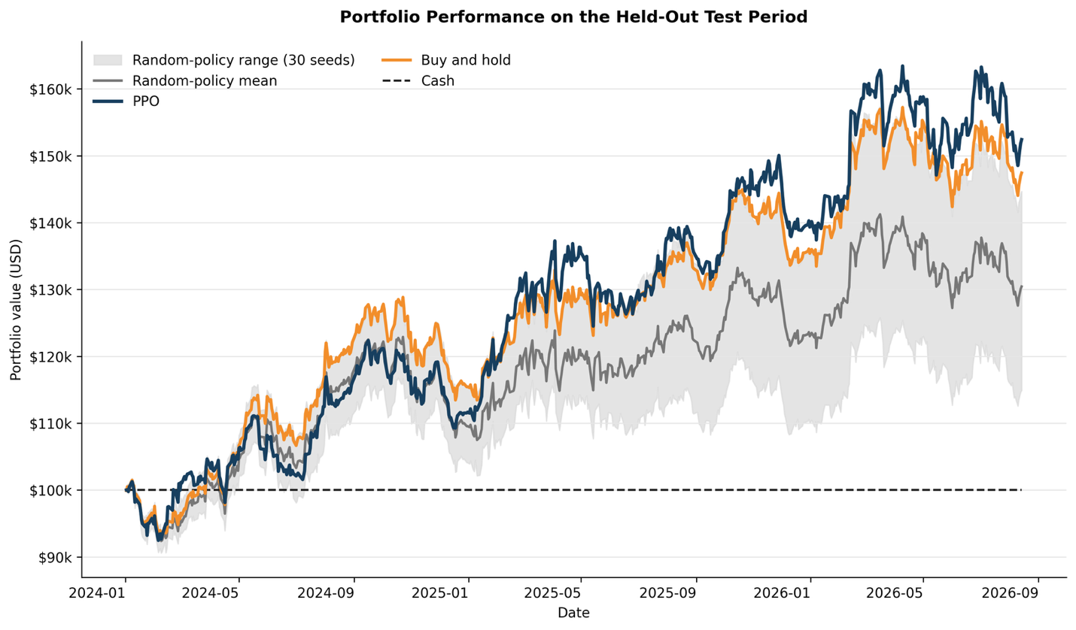
Figure 4. Portfolio values over the held-out test period from Jan 2 2024 to Aug 14 2026. The shaded area shows the daily minimum-to-maximum range across 30 random-policy seeds.

User Testing

Pre-User Testing

Before recruiting user testing participants, I ran 5 structured pre-test sessions against the live system. I sent 3 questions each time to the chat endpoint:
- a portfolio-status question,
- a question about one specific held stock
- a request for overall portfolio advice.

I found 4 problems:
- The system creates a realistic sounding company name for ticker SO (Southern Company) almost every time it is mentioned. It returned 4 different wrong names across the 5 test runs including "Semiconductors of America," and "Southwestern Energy". It seems that the company name is generated from the language model's own recall rather than being looked up from real data.
- A reproducible 500 Internal Server Error occurred when asking about a specific held stock (AEP), reproduced 4 times across 2 sessions with different phrasing.
- On 2 occasions, the agent returned its own internal tool-call syntax (e.g. {"name":"get_stock_return_prediction","parameters":{"ticker":"AEP"}}) as the reply instead of executing the tool.
- Trade recommendations always cover all 5 tickers the PPO agent was trained on, regardless of whether the user holds them, and the response does not distinguish held from unheld tickers when suggesting a sale.

Another big issue is that none of the 15 responses explained what the model's "signal percentile" number means. Also, the strength label attached to it (e.g. "strong," "weak") was applied inconsistently across similar values.

A positive finding was that the tone of the responses was appropriate for low financial literacy users. Also the saved portfolio values were used accurately whenever the user requested that information.

User Study

The user study assessed whether non-technical users can understand and act on the recommendations the system produces, and whether the interface is usable. I recruited 5 participants who self-identify as non-technical investors (i.e. they own or are interested in stocks but have no background in finance or machine learning).
I gave each participant the same scenario: they hold a portfolio of 5 stocks and have a small amount of cash available. They have to use the web chat interface to ask the advisor bot about each stock in turn and ask for an overall portfolio view.
After each recommendation was displayed, I asked each participant 3 questions:
- What does the system recommend you do with this stock?
- What is the main reason given for that recommendation?
- How confident is the system in this recommendation?
These questions check whether participants can understand the key information from the plain-language output. I marked a response correct if it matches the structured model output that generated the explanation.
Participant Name:
Interaction | System's actual recommendation | Participant: what was recommended? | Participant: what reason given? | Participant: how confident?
Stock 1 (NEE)
Stock 2 (SO)
Stock 3 (DUK)
Stock 4 (AEP)
Stock 5 (EXC)
Overall portfolio
Overall accuracy: [x / 18 correct]
Comments:

Aggregate comprehension accuracy: [x / 90]
SUS score (average across 5): [ ]
Recurring feedback themes: [ ]
Interface changes made as a result: [ ]

THIS CHART WILL BE REPEATED 5 TIMES WITH USERS FEEDBACK.

Conclusion
NEED TO UPDATE

Bibliography

OpenAI – Spinning Up – User Documentation
https://spinningup.openai.com/en/latest/algorithms/ppo.html
An educational resource focussed on Deep Learning with Reinforcement Learning.

StableBaseline3 – Open Source RL Library Github Repo
https://github.com/DLR-RM/stable-baselines3
Production ready, Open Source RL Library built with PyTorch.

Gymnasium – OpenAI Gym Environment Github Repo
https://github.com/Farama-Foundation/Gymnasium
Open Source library for training and testing Reinforcement Learning models.

System Usability Scores – Wikipedia
https://en.wikipedia.org/wiki/System_usability_scale
Measures the usability of a system.

Yfinance Library – User Documentation
https://ranaroussi.github.io/yfinance/
Open Source finance data in Python.

References
Wei, D. (2019). Prediction of Stock Price Based on LSTM Neural Network. 2019 International Conference on Artificial Intelligence and Advanced Manufacturing (AIAM), 544–547. https://doi.org/10.1109/AIAM48774.2019.00113

Mostafavi, S. M., & Hooman, A. R. (2025). Key technical indicators for stock market prediction. Machine Learning with Applications, 20, 100631. https://doi.org/10.1016/j.mlwa.2025.100631

Ding, G., & Qin, L. (2020). Study on the prediction of stock price based on the associated network model of LSTM. International Journal of Machine Learning and Cybernetics, 11(6), 1307–1317. https://doi.org/10.1007/s13042-019-01041-1

Jiang, Z., Xu, D., & Liang, J. (2017). A Deep Reinforcement Learning Framework for the Financial Portfolio Management Problem. arXiv:1706.10059. https://arxiv.org/abs/1706.10059

Zou, J., Lou, J., Wang, B., & Liu, S. (2024). A novel Deep Reinforcement Learning based automated stock trading system using cascaded LSTM networks. Expert Systems with Applications, 242, Article 122801. https://doi.org/10.1016/j.eswa.2023.122801

